|  |
| --- |
|  |
| Design Document (Term Project) |
| FindMyPhone |
|  |
| **Authors: Chris Card, Gurpreet Nanda, Tony Nguyen** |
| **11/5/2012** |

|  |
| --- |
| FindMyPhone application. Done at Colorado School of Mines in the Android Programming Class. |

Table of Contents

Application Declaration and Definition 3

User Stories 3

Use Case List 4

Top Three Priorities 4

Use Case Diagram 4

Use Case 5

Customer locates his devices 5

Main Success Scenario 5

Customer adds/removes devices 6

Customer creates account/logs into account 7

Domain Analysis 8

Domain Objects 8

# Application Declaration and Definition

Creating a find my phone application that will allow a user to play a tone, send a message to the phone, and find the phone's location while being logged in a different phone or tablet. User will be able to do all this from an account created by them using the application

# User Stories

In a land far, far away, in the kingdom of Firefall there was a curse bestowed upon them causing the disappearance of many a phone. The king and the villagers did not know how to break this curse, one day three strangers appeared out of the setting sun. Declaring they will break the curse if king will give them the golden Nexus 7. The King reluctantly agreed to the request of these strangers. One of the strangers pulled out their phone and asked the king for his google user account. The king, perplexed, obliged the request and the stranger login into the app. the stranger selected the king’s phone from his devices. The stranger sent the phone the message "I don't have a lot of money but I have a particular set of skills that makes me a night mare for people like you.” The stranger then selected the option "display location" and saw on the map that the king's phone was in the great Bakos the dragon’s lair. The strange three traveled to the lair and demand the great Bakos return phones, the dragon laughed and said "if you give me the great ruby.rb then I will the phones.” The strange three decided to have the kings phone play "Friday" by Rebecca Black until the great said "enough i can't take it any longer here are the phones". The strange three returned triumphant and with the golden nexus 7 they found where next tablet of legend lay. The king then opened the app on his phone and sent the "liar liar pants on fire message to the golden nexus 7" and the strange three where consumed by the great dragon Bakos fiery breath.

# Use Case List

1. Mister Forgetful creates account
2. Mister Forgetful adds or removes devices
3. Mister Forgetful finds location of devices
4. Mister Forgetful plays noises or locks devices
5. Mister Forgetful sends message to devices

## Top Three Priorities

1. Mister Forgetful must be able to find location of his devices
2. Mister Forgetful must be able to add or remove his devices
3. Mister Forgetful must be able to create and log into his account

# Use Case Diagram

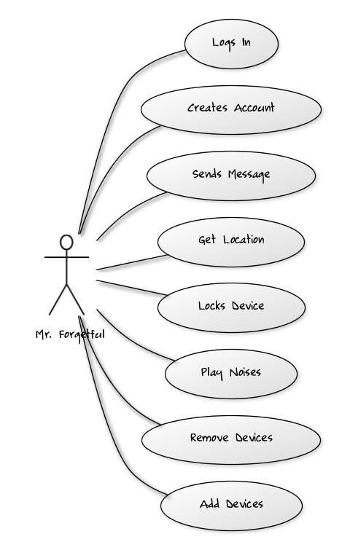

# Use Case

## Customer locates his devices

Main Success Scenario  
In order to locate a device, the customer should be able to locate the device using get location. When starting the application, the customer will be prompted to insert their username and password. When the customer successfully logs in, the customer will be given a list of the current devices added and will be able to locate the device by pressing the FindMe button. When this happens the application will show the customer where the device is located via google maps.  
  
Alternate Scenarios  
 Unable to get location of device  
 If the device is turned off or the device has no more battery life, the customer will see the  
 message “could not locate device”  
   
 Device does not exists  
 If the device added was done incorrectly then the customer will see the message “device not valid”

Device does not have network access

If the device is not in range of any network location and cannot connect to the the network the customer will see the message “could not locate device”

Server is not running

If the device is connected but the server is not on the customer will see the message “could not connect to server”

Customer adds/removes devices

**Title:** As a customer I want to add my devices or remove them so I can locate, lock, send messages, or play noises to them.

**Primary Actor:** Customer  
  
**Stakeholders & Interest:**  Customer wants to add or remove devices  
  
**Preconditions:** Customer accesses the application and logs in or creates account  
  
**Post conditions:** List of devices is shown, can be empty   
  
**Main Success Scenario:** Customer can remove or add devices  
  
**Extensions:**  1. Removing device failed

2. The message “Device does not exist” is displayed

3. Stored device information could not be retrieved due to technical problems

4. The message “could not retrieve devices” is displayed

**Special Requirements:** Customer must be logged in  
  
**Technology & Variation List:** None  
  
**Frequency:** None  
  
**Open Issues:** What if devices cannot connect to network?

What if devices cannot connect to server?

What if devices are turned off?

Customer creates account/logs into account  
  
Main Success Scenario  
To be able to locate, lock, send messages, or play noises to other devices, a customer must first create an account. Once the (forgetful) customer downloads the application, he/she will be able to create an account with a valid username and a password. The customer may then log into the account or create a new account again.

## Domain Analysis

### Domain Objects

**User:** The person using this service

**Account:** A service that allows users to store devices in a list. A collection of devices

**Devices:** An item belonging to user to be used to find other items

**Location:** Where the device is located

**Message:** A text that can be displayed on devices

**Alert/Response:** Allows device to lock another device

Account 🡪 Many Devices

Device 🡪 Get location of other devices

Device 🡪 Locks other devices

Device 🡪 Sends Messages to other devices

